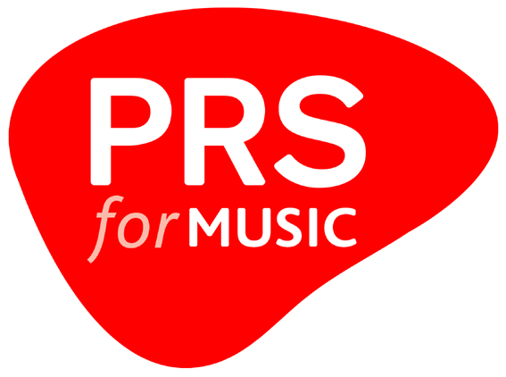
Television channel blanket licence
application form

Please note: no licence, whether expressed or implied, shall be taken
to have been granted by PRS for Music merely by completion of this form.

Section 1 – Licensee information

A) Applicant details

Company name:

Registered address:

Company registration number:

B) Contact details

Name:

Job position/title:

Address:
(if different to above)

Telephone number:

Email address:

Website:

Section 2 – Channel information

A) Channel details

Channel name:

Channel launch date:

Estimated number of hours of music broadcast per week:

How many hours of in-house content will be broadcast per day?

How many hours of acquired content will be broadcast per day?

Will you be broadcasting advertisements/ commercials? | Yes | No

Is the channel BARB rated or will it become BARB rated at a later date? | Yes | No

Please provide a brief description of your channel:

Please list the channel/EPG number for each platform on which the channel is broadcast in the UK:

Sky: |  | Freesat: |  | Freeview: |  | Virgin Media:

Please list details of any territories outside the UK which receive the channel directly:

Territory of reception | Feed name/  number* | Number of homes reached by channel via satellite | Comments

*Feed name/number must be listed in order to indicate whether a signal(s) to other territories are broadcast via a single territory or multi- territory feed. E.g. Feed 1: Belgium, Holland, Germany, France; Feed 2: Poland, Hungary, Romania.

B) Playout information

Company responsible for ‘playout’:

Website:

Contact e-mail:

Contact phone:

Territory in which signal ‘playout’ or broadcast originates:

Complete and send this form to the broadcast licensing team at tvchannels@prsformusic.com.

Or Broadcast Licensing, PRS for Music, 2 Pancras Square, London NC1 4AG.

Questions? Call +44 (0)20 3741 4151 to speak to one of our Broadcast Licensing Consultants

